CE265 – Concrete Lab Report
Please follow the standard the standard report format described on the website.

Summary

What have you done, and what results have you determined. What do they mean. E.g. Table 1 is a summary of the results obtained . The role of w/c ratio was found to be.
Table 1: Summary of Results
Concrete Properties | Average Values
f_{c} (MPa)
ε_{c}
E_{c} (GPa)
f_{t} (MPa)

- Test Set Up
- Describe the following briefly.
- Test machine and data collection method
- Test set-up of compressive test (Fig. 1)
- Test set-up of split test (Fig. 1)
P
P
d
Figure 1: Specimen and Loading
(b) Split Cylinder Test
L

  - Data Analysis
- Measured Values
Table 2: Specimen Dimensions
Test Type | Specimen No. | Diameter d (mm) | Length L (mm)
Compressive  Test | Cyl-1
Compressive  Test | Cyl-2
Split Test | Cyl-3
Observations: Describe the test cylinders – are they uniform? Are some holes and pores visible, can you see lines between different scoops of concrete, etc.
Table 3: Failure Loads
Test Type | Specimen No. | Peak Load (kN) | Failure Load (kN)
Compressive  Test | Cyl-1
Compressive  Test | Cyl-2
Split Test | Cyl-3
- The peak load for the split test should also be its failure load.
- Introduce the following properties of concrete: maximum compressive strength (f_{c}), maximum tensile strength (f_{t}), the Modulus of Elasticity (E), and the compressive strain (ε_{c}), explain what they are.
Table 4: Concrete Properties
Test Type | Specimen No. | Strength (MPa) |  | E_{c} (GPa) | ε_{c}
Test Type | Specimen No. | f_{c} | f_{t} | E_{c} (GPa) | ε_{c}
Compressive Test | Cyl-1
Compressive Test | Cyl-2
Split Test | Cyl-3
Table 5: Comparison of Properties
 |  | Your Group Avg | Total Average | Total Std Dev
Compression | f_{c}
Modulus | E_{c}
Tension | f_{t}
Table 5 is to describe the variability in material properties. The more samples taken (the whole group) the more representative the properties are.
Role of w/c ratio
Plot the average compressive and tensile failure stress versus w/c ratio for all tests. Discussion observations of the type of failure, the nature of the concrete during casting, and the results.
Background
Maximum compressive strength is calculated by:
$f_{c^{'}}=\frac{P}{A}$ (Formula 1)
where P is the peak load (Table 3) and A is the cross sectional area of the cylinder. Refer to Lab #1 for units.
Maximum Tensile strength is calculated by:
$f_{t}=\frac{2P}{π\text{dL}}$ (Formula 2)
where P is the peak load (Table 3)under tensile (split) testing. L and d are length and diameter respectively (Table 2).
Maximum Compressive strain is calculated by:
$ε_{c}=\frac{ΔL}{L}$ (Formula 3)
where ΔL = L_{final}-L_{initial} and L is the length (Table 3)
Modulus of elastic E_{c} is defined as the slope of a line (secant) connecting the origin and the point corresponding to 0.4 f_{c} in the stress-strain.
Note: The displacement measurement in the equipment is not that accurate, so this will create inaccuracies in the strain and E-modulus values.
Plot Stress-Strain Curves
Stress-Strain curves of a representative compressive tests should be plotted for one of each of the base mix and the wet/dry mix. You should first normalize the data in order to get rid of the data prior to start of testing.
Description of Cylinder Failure
- Note how the cylinders fail under compression. Explain whether the aggregate or the cement is responsible for the failure.
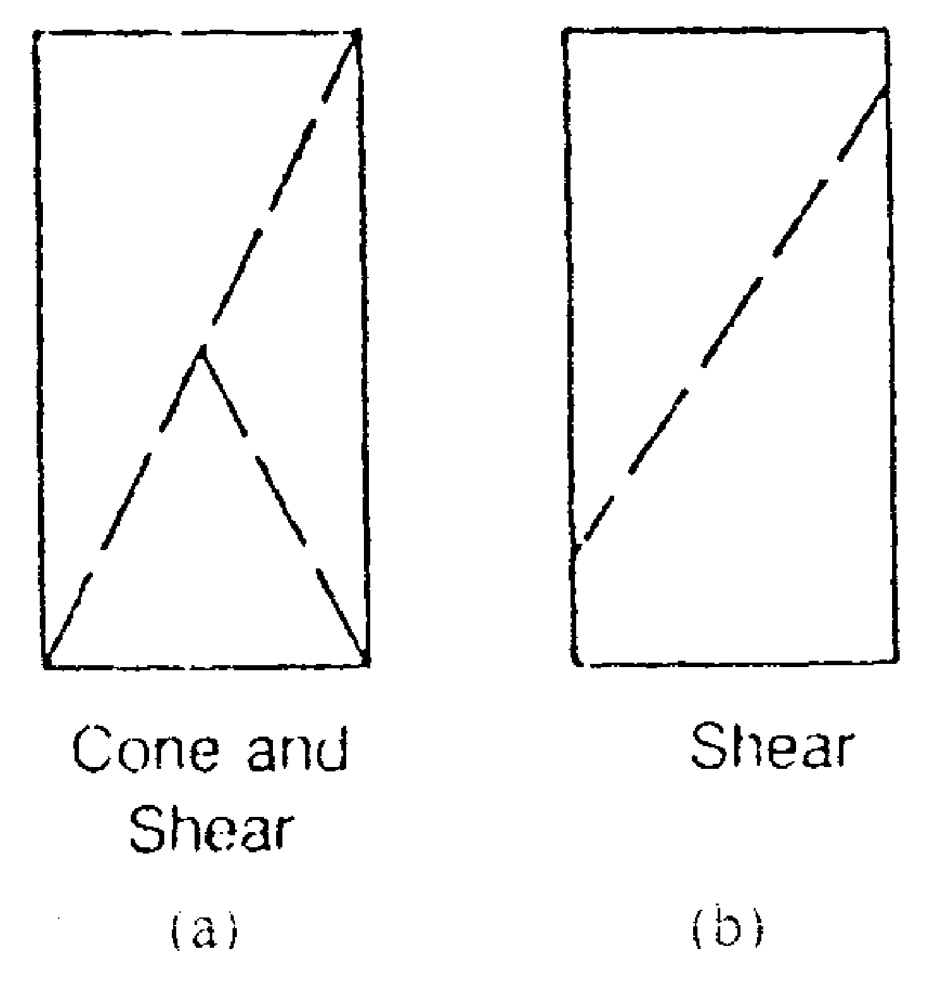
Figure 6 – Common Concrete Failure
- The two most common types are shown in figure 6. Frank will point them out to you as they happen.
4.0 Concluding Remarks
- Include your conclusions here; make sure you refer to the results of this lab.

